SAMPLE SCREENS
Screen shots

Cloud Server Login

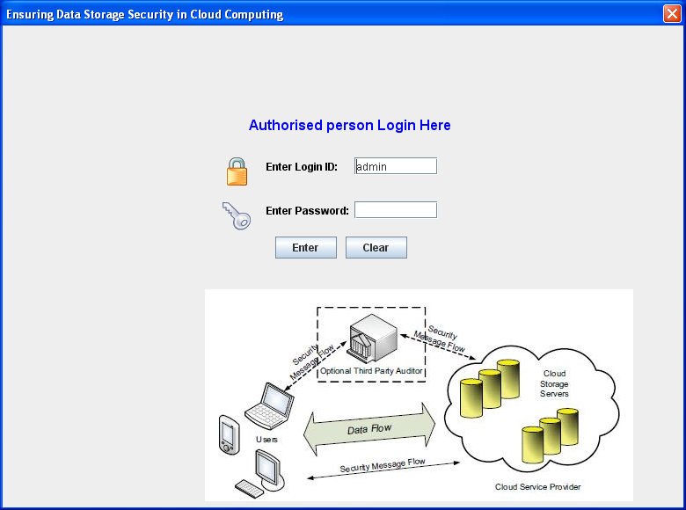

Client side Login

